**Operating System Lab**

**Lab Report : 01**



**Fall 2019**

**Operating System**

Submitted By : **Naveed Ahmad**

Registration No : **17PWCSE1507**

Class Section: **B**

“On my honor, as student of University of Engineering and Technology, I have neither given nor received unauthorized assistance on this academic work.”

Submitted to:

**Dr. Tariq Kamal**

**Department of Computer Systems Engineering**

**University of Engineering and Technology, Peshawar**

**Lab Report : 01**

**Basic Ubuntu Commands**

**Objective:**

To know about the Ubuntu Basic Commands and there uses.

## Tasks :

1. **Whoami :**

This command tell us about the user that which user is currently login.

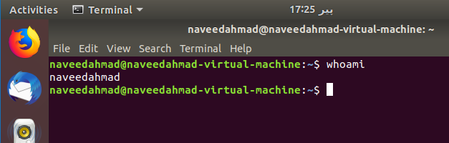

1. **Ifconfig :**

ifconfig in short “interface configuration”.

The “ifconfig” command is used for displaying current network configuration information, setting up an IP address, netmask or broadcast address to an network interface,

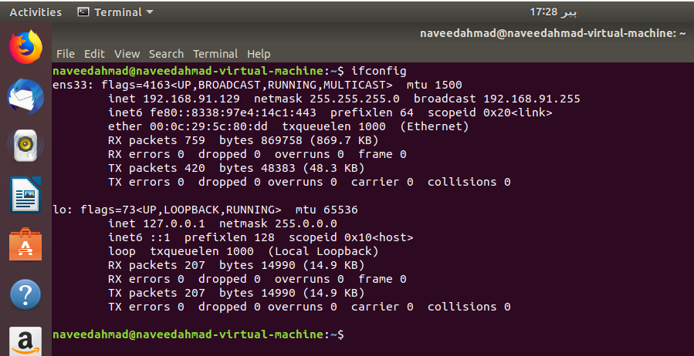

1. **uname -a :**

This command print information about the current system. Is displays kernel name , kernel release , version , machine hardware name and operating system.

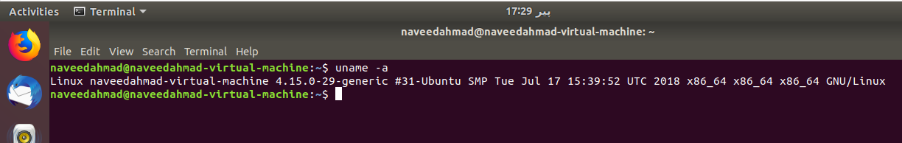

1. **diff file1.txt file2.txt :**

diff stands for **difference**. This command is used to display the differences in the files by comparing the files line by line.

it tells us which lines in one file have is to be changed to make the two files identical.

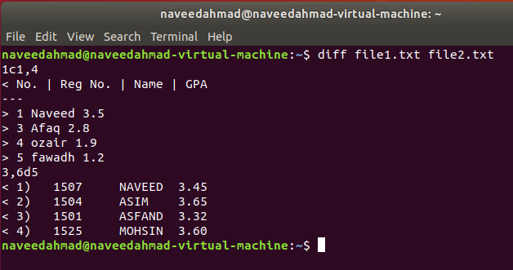

1. **ls -a :**

Ls is used for listing all the directries

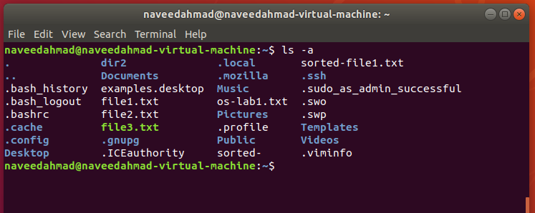

1. **cat file1.txt :**

The cat command short for “concatenate “. cat command allows us to create single or multiple files. It is used for displaying the content in the file.

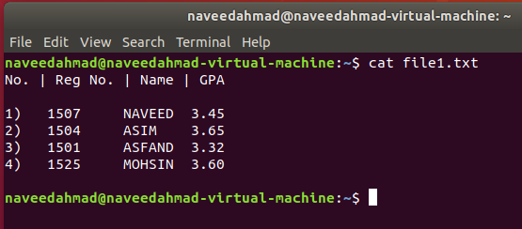

1. 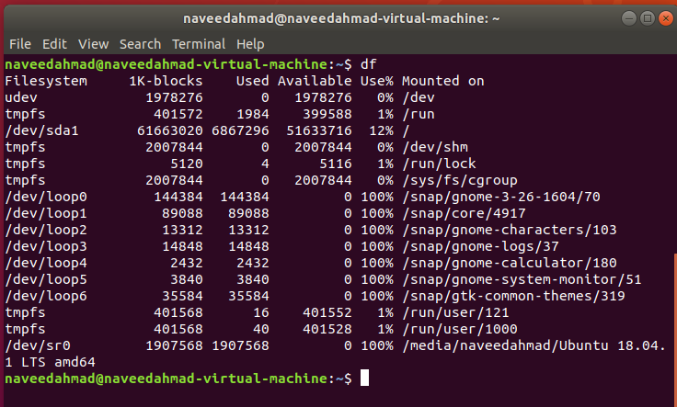**df :** abbreviation for “disk free .It is used to display the amount of available disk space for file systems. i-e the size of the file .
2. **cp file1.txt file2.txt :**

Cp  command is used for copying files and directories. Here above I am using cp command to copy file into new file1.

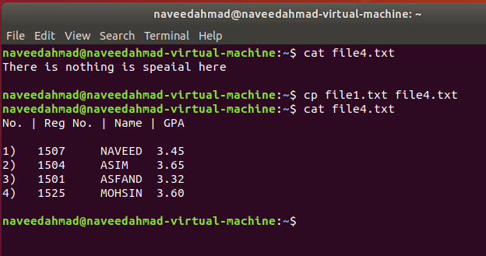

1. **mv file1.txt file2.txt :**

Used for moving file to another file.

All the data from one file is moved to other file and file one is deleted.

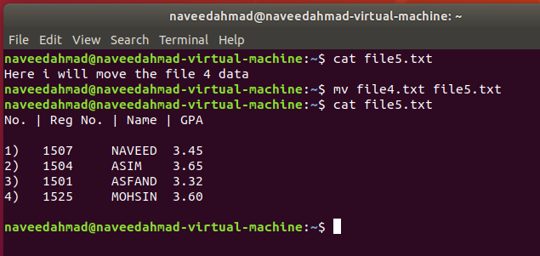

1. **cp -r dir1 dir2 :**

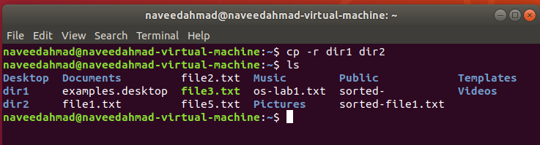copy dir1 to dir2 and create dir2 if it doesn't exist

1. **find / -name file1.txt -print :**

This command find searches for files in a directory .It find and locates files on your system Within each directory

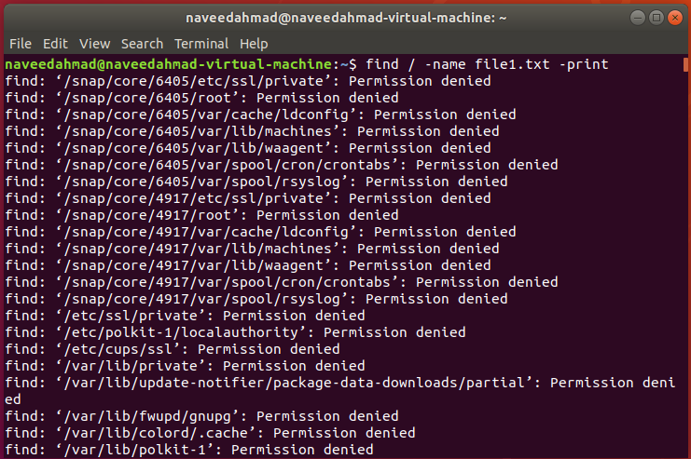

1. **du :**

**du** command, short for disk usage, is used to estimate file space usage.  
The du command can be used to track the files and directories which are consuming excessive amount of space on hard disk drive.

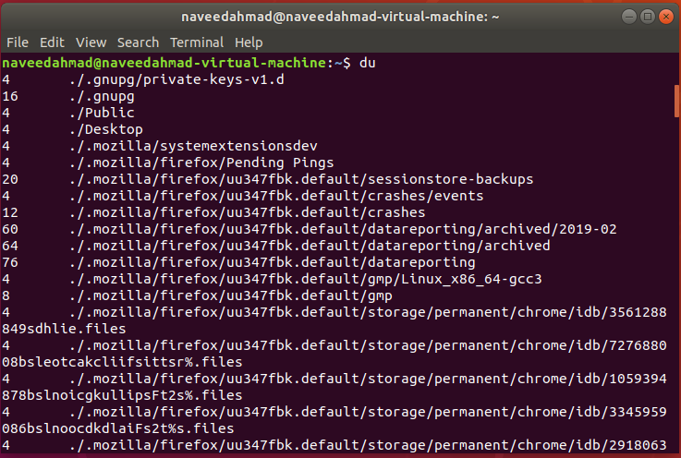

1. **exit :**

It quit the terminal window or log out of current session.

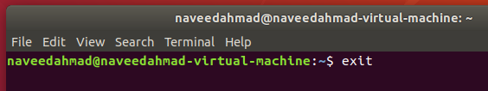

1. **shutdown -h now :**

This command shutdown the ubuntu Operating System.

